**Summary of Results of using Daubechies in Denoising Heart Sound with Noise using the Implemented Algorithm in the FPGA**

| **Daubechies** | | | | | | | |
| --- | --- | --- | --- | --- | --- | --- | --- |
| **Wavelet used** | | **SNR (dB)** | **SNR** | **RMSE** | **PRD** | **CC** | **Percentage Error** |
| **db2** | |  | | | | |  |
| **No. of Levels** | **2** | 23.2454 dB | 211.1251 | 0.0001123 | 6.8822% | 0.95547 | 9.5351% |
| **3** | 23.3998 dB | 218.7661 | 0.0001119 | 6.761% | 0.95628 | 9.2096% |
| **4** | 23.9161 dB | 246.3826 | 0.00010539 | 6.3708% | 0.96135 | 8.4391% |
| **5** | 24.137 dB | 259.2388 | 0.00010275 | 6.2108% | 0.96316 | 8.8472% |
| **db3** | |  | | | | |  |
| **No. of Levels** | **2** | 23.347 dB | 216.1225 | 0.0001126 | 6.8022% | 0.95573 | 8.5529 |
| **3** | 23.5453 dB | 226.2195 | 0.00011 | 6.6487% | 0.95789 | 9.4705 |
| **db4** | |  | | | | |  |
| **No. of Levels** | **2** | 23.5194 dB | 224.8744 | 0.00011037 | 6.6685% | 0.95758 | 8.7317% |
| **db5** | |  | | | | |  |
| **No. of Levels** | **2** | 23.6881 dB | 233.7814 | 0.00010664 | 6.5403% | 0.96041 | 9.0610% |
| **db6** | |  | | | | |  |
| **No. of Levels** | **2** | 23.8038 dB | 240.0933 | 0.00010517 | 6.4537% | 0.96136 | 9.7349% |

db2 - 2 levels

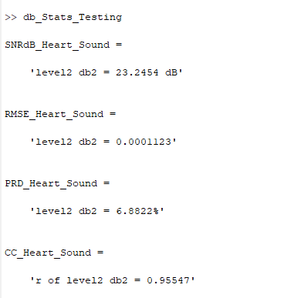

**db2 - 3 levels**

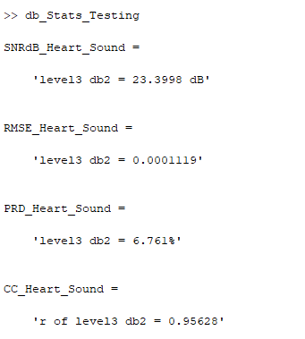

**db2 - 4 levels**

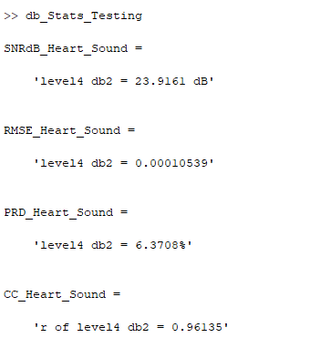

**db2 - 5 levels**

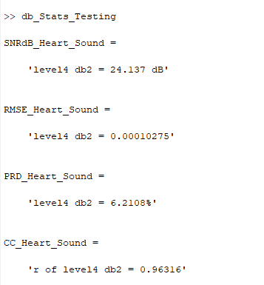

**db3 - 2 levels**

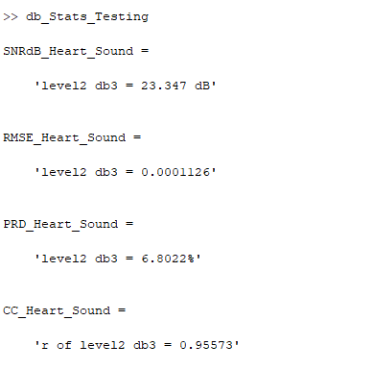

**db3 - 3 levels**

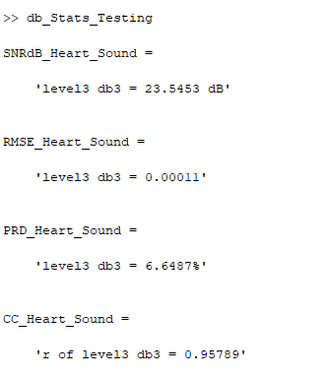

**db4 - 2 levels**

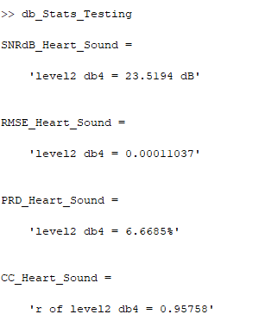

**db5 - 2 levels**

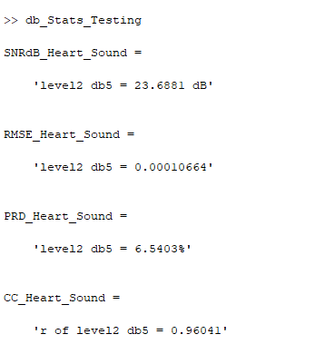

**db6 - 2 levels**

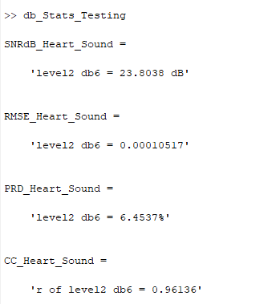

**Summary of Results of using Symlets in Denoising Heart Sound with Noise using the Implemented Algorithm in the FPGA**

| **Symlets** | | | | | | | |
| --- | --- | --- | --- | --- | --- | --- | --- |
| **Wavelet used** | | **SNR (dB)** | **SNR** | **RMSE** | **PRD** | **CC** | **Percentage Error** |
| **sym2** | |  | | | | | |
| **No. of Levels** | **2** | 23.451 dB | 221.3604 | 0.00010959 | 6.7213% | 0.95809 | 8.1456% |
| **3** | 23.5877 dB | 228.4389 | 0.00010791 | 6.6163% | 0.95948 | 8.9584% |
| **4** | 24.1194 dB | 258.2903 | 0.00010291 | 6.2235% | 0.963 | 9.9860% |
| **5** | 24.3286 dB | 270.9318 | 0.00010047 | 6.0753% | 0.9647 | 9.2806% |
| **sym3** | |  | | | | | |
| **No. of Levels** | **2** | 23.5966 dB | 228.9075 | 0.00010776 | 6.6095% | 0.95955 | 9.5435% |
| **3** | 24.0358 dB | 253.2678 | 0.00010401 | 6.2836% | 0.96231 | 7.1803% |
| **sym4** | |  | | | | | |
| **No. of Levels** | **2** | 23.9659 dB | 249.2241 | 0.00010331 | 6.3344% | 0.96284 | 8.7401% |
| **sym5** | |  | | | | | |
| **No. of Levels** | **2** | 24.0671 dB | 255.0997 | 0.00010217 | 6.261% | 0.96316 | 9.3871% |

Sym 2 - level 2

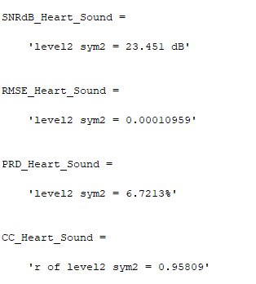

Sym 2 - level 3

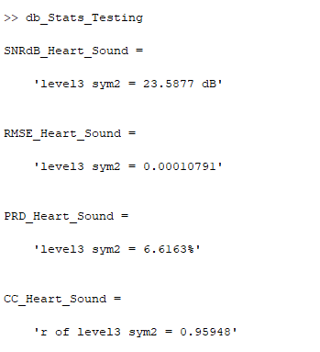

Sym 2 - level 4

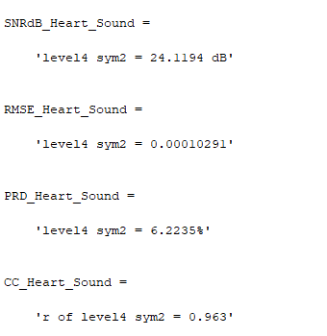

Sym 2 - level 5

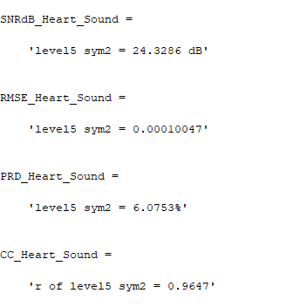

Sym 3 - level 2

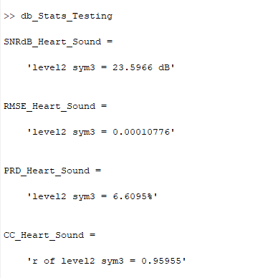

Sym 3 - level 3

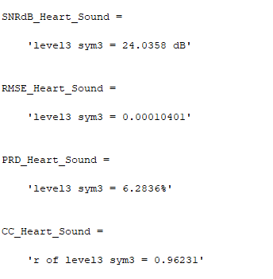

Sym 4 - level 2

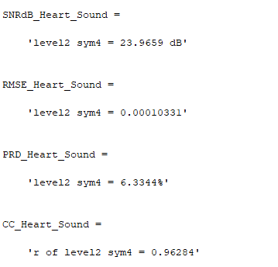

Sym 5 - level 2

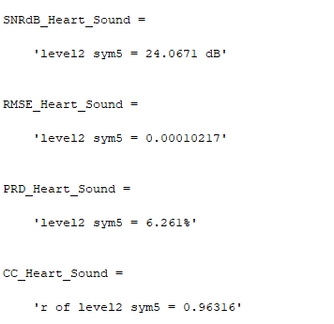

**Summary of Results of using Coiflets in Denoising Heart Sound with Noise using the Implemented Algorithm in the FPGA**

| **Coiflets** | | | | | | | |
| --- | --- | --- | --- | --- | --- | --- | --- |
| **Wavelet used** | | **SNR (dB)** | **SNR** | **RMSE** | **PRD** | **CC** | **Percentage Error** |
| **coif1** | |  | | | | | |
| **No. of Levels** | **2** | 23.7361 dB | 236.3796 | 0.00010613 | 6.5042% | 0.96024 | 9.1448% |
| **3** | 24.1582 dB | 260.5074 | 0.0001025 | 6.1957% | 0.96344 | 6.4207% |
| **coif2** | |  | | | | | |
| **No. of Levels** | **2** | 24.9876 dB | 315.3262 | 9.3182e-05 | 5.6315% | 0.96979 | 8.9647% |

**Coif 1 - level 2**

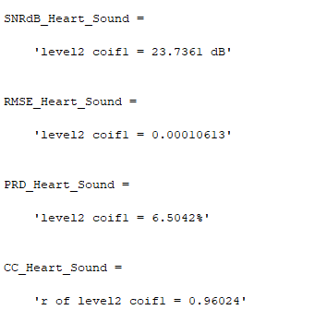

**Coif 1 - level 3**

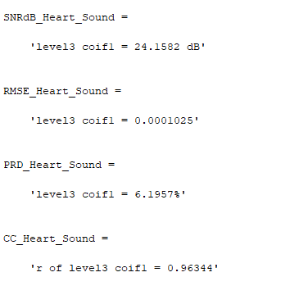

**Coif 2 - level 2**

